MATHEMATICS METHODS

MAWA Semester 1 (Unit3) Examination 2017

Calculator-Assumed

Marking Key

© MAWA, 2017
Licence Agreement
This examination is Copyright but may be freely used within the school that purchases this licence.
- The items that are contained in this examination are to be used solely in the school for which they are purchased.
- They are not to be shared in any manner with a school which has not purchased their own licence.
- The items and the solutions/marking keys are to be kept confidentially and not copied or made available to anyone who is not a teacher at the school. Teachers may give feedback to students in the form of showing them how the work is marked but students are not to retain a copy of the paper or marking guide until the agreed release date stipulated in the purchasing agreement/licence.

The release date for this exam and marking scheme is
- the end of week 8 of term 2, 2017

Section Two: Calculator-assumed (100 Marks)

Question 8

Solution
$V=\frac{1}{3}πr^{2}h=\frac{4}{3}πh^{3}$
When $V=60, h={(\frac{3×60}{4×π})}^{1/3}≈2.4286$
and $\frac{dV}{dh}=4πh^{2}≈4π{×2.4286}^{2}≈74.1$
$δV≈\frac{dV}{dh}δh$
Since $δV=1,$ $δh≈1/74.1≈0.0134$
So the height increases by about 13 millimetres

Marking key/mathematical behaviours | Marks
- expresses the volume as a function of height only  - evaluates $h$  - differentiates correctly and evaluates $\frac{dV}{dh}$  - uses increments formula correctly  - gives correct answer | 1  1  1+1  1  1

Question 9(a)

Solution
$$f^{'}\left(x\right)=10e^{-x}\cos{x-{10e}^{-x}\sin{x}}$$
$$f^{''}\left(x\right)={10e}^{-x}(-\cos{x-\sin{x)}}-{10e}^{-x}(\cos{x-\sin{x)}}$$
Marking key/mathematical behaviours | Marks
- determines $f'(x)$ correctly  - determines $f''(x)$ correctly | 1  1

Question 9(b)

Solution
$f^{'}\left(x\right)=10e^{-x}(\cos{x-\sin{x)}}=0$ when $\cos{x=\sin{x}},$ i.e. $x=π/4$
$f^{''}\left(x\right)=-20e^{-x}\cos{x}$ and so $f^{''}\left(π/4\right)<0$
so $f\left(π/4\right)$ is a local maximum.
Since there is only one local maximum and $f\left(0\right)=f\left(π\right)=0$
$f\left(π/4\right)=\frac{{10e}^{-π/4}}{\sqrt{2}}$ is the maximum.
$\frac{e^{-π/4}}{\sqrt{2}} ≈3.224$ correct to 4 significant figures
Marking key/mathematical behaviours | Marks
- finds zeros of $f'(x)$  - obtains $f^{''}\left(π/4\right)<0$ and uses second derivative test correctly  - obtains exact value of $f(π/4)$  - evaluates $f\left(π/4\right)$correct to 4 significant figures | 1  1+1  1  1

Question 9(c)

Solution
$f^{''}\left(x\right)=-20e^{-x}\cos{x}=0$ when $x=π/2$
Since $f^{''}\left(x\right)$ changes sign at $x=π/2,$ there is a point of inflection at $x=π/2$
The point of inflection has coordinates $(π/2,{10e}^{-π/2}\sin{π/2)=}(π/2,{10e}^{-π/2})$

Marking key/mathematical behaviours | Marks
- finds the zero of $f''(x)$ for $0≤x≤π$  - finds correct answer | 1  1

Question 9(d)

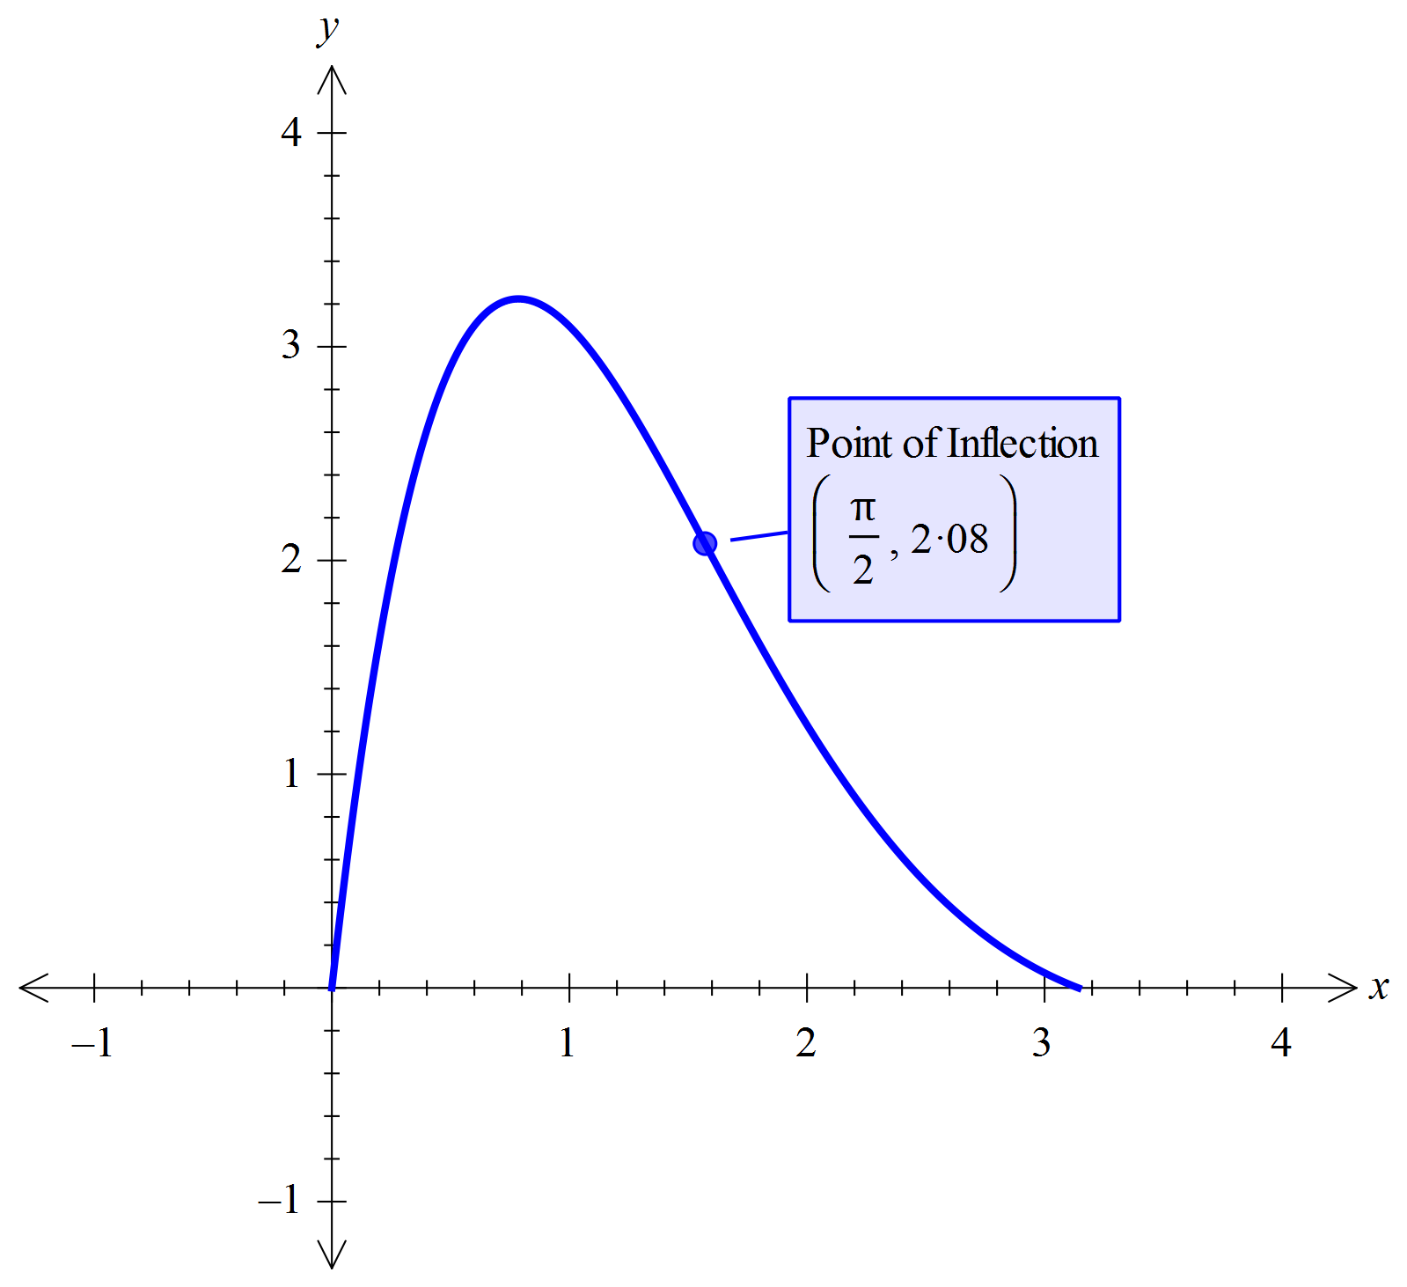Solution

Marking key/mathematical behaviours | Marks
- graph has right ‘shape’, correctly plotted maximum turning point (at $x=π/4≈0.78$), non-zero derivatives at end points  - inflection point indicated correctly | 1+1+1  1

Question 10(a)

Solution
Isotope $α$ decays faster because it takes less time for it to lose half of its weight.
Marking key/mathematical behaviours | Marks
- justifies answer correctly. | 1

Question 10(b)

Solution
$$A_{0}=A\left(0\right)=8.5$$
$$e^{-5.8k}=\frac{1}{2}$$
$⟹k=\frac{\ln{2}}{5.8}≈0.1195$ (calculator)
Marking key/mathematical behaviours | Marks
- evaluates $A_{0}$ correctly  - uses $e^{-5.8k}=\frac{1}{2}$  - evaluates $k$ accurately | 1  1  1

Question 10(c)

Solution
$A\left(t\right)=8.5e^{-0.1195t}=0.001$
$⟹t≈\frac{\ln{0.001-\ln{8.5}}}{-0.1195}≈75.7$ (or directly from calculator)
So it takes 75.7 years
Marking key/mathematical behaviours | Marks
- uses correct equation  - solves accurately | 1  1

Question 10(d)

Solution
$$B\left(t\right)=2e^{-ωt}$$
where $e^{-7.6ω}=\frac{1}{2}$ i.e. $ω≈0.0912$ (calculator)
$$8.5e^{-0.1195t}=2e^{-0.0912t}$$
$$⟹\ln{8.5-0.1195t=}\ln{2-0.0912t}$$
$⟹t=\frac{\ln{8.5-\ln{2}}}{0.1195-0.0912}≈50.065$ (or directly from calculator)
So the amounts of the two isotope will be equal in weight 50.065 years from now.
Marking key/mathematical behaviours | Marks
- determines $ω$ accurately  - uses $8.5e^{-0.1195t}=2e^{-0.0912t}$  - solves accurately  - interprets solution correctly | 1  1  1  1

Question 11(a)

Solution
Alternatively, use the statistics app of a graphic calculator – setting up list 2 as the frequency.
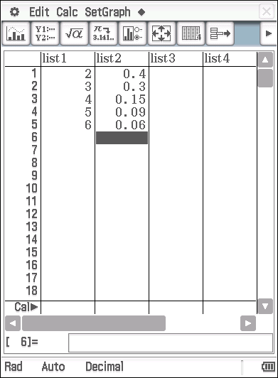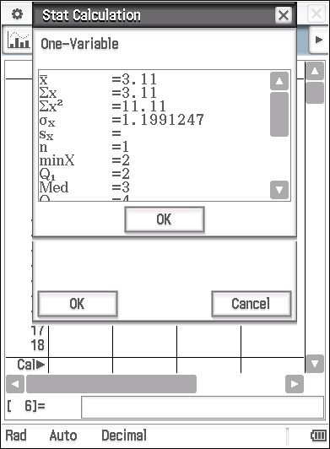
Marking key/mathematical behaviours | Marks
- Applies the expected value formula  - States the correct result | 1  1

Question 11(b)

Solution
Alternatively, use the statistics app of a graphic calculator – and square produced in part (a), namely
Marking key/mathematical behaviours | Marks
- Applies the expected value formula  - States the correct result | 1  1

Question 11(c)

Solution

Marking key/mathematical behaviours | Marks
- correctly calculates end points  - correctly converts to discrete values  - correctly calculates probability | 1  1  1

Question 12(a)
Solution
The random variable represents the probability that a respondent regularly uses social media. Let to represent that a respondent does NOT regularly use social media, and
to represent that a respondent does regularly use social media.
Then, the probability distribution will be defined as in the table below.

x | 0 | 1
P(X = x) | 0.35 | 0.65

Marking key/mathematical behaviours | Marks
- Defines P(X = x)  - Provides the correct values for the Probability of the two possible values of x. | 1  1

Question 12(b)
Solution
The random variable, produces a Bernoulli distribution

Marking key/mathematical behaviours | Marks
- Indicates a Bernoulli distribution | 1

Question 12(c)
Solution

Marking key/mathematical behaviours | Marks
- States the correct result for (i)  - States the correct result for (ii) | 1  1

Question 12(d)
Solution
Marking key/mathematical behaviours | Marks
- Recognises the correct probability  - Applies the multiplication principle | 1  1

Question 13(a)
Solution
Probability of Susan not stopping
Marking key/mathematical behaviours | Marks
- Indicates that the probability of light not being red is 0.85  - Applies the multiplication principle and states the correct result | 1  1

Question 13(b)
Solution
x | 0 | 1 | 2 | 3
 | 0.614125

Alternatively,
Use the binomial distribution app on a CAS calculator, e.g. for
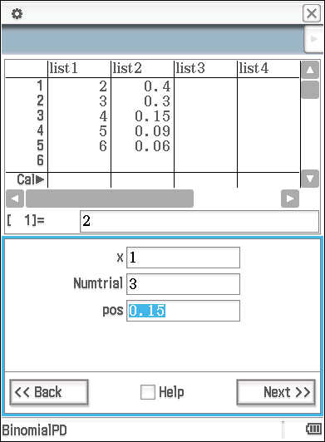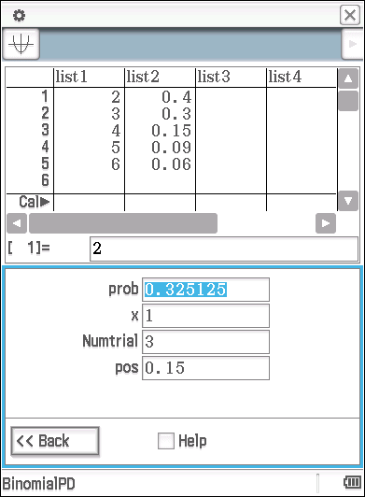

Marking key/mathematical behaviours | Marks
- Indicates use of the Binomial probability distribution  - States the correct probabilities for | 1  1+1+1

Question 13(c)
Solution
As the distribution is Binomial with

Or alternative 2,

And alternative 3, use a CAS calculator and enter the data from part (b) into list1 and list2 of the Statistics App as indicated below and with list 2 set as the frequency use the one-variable stat calculations to write down the mean and SD
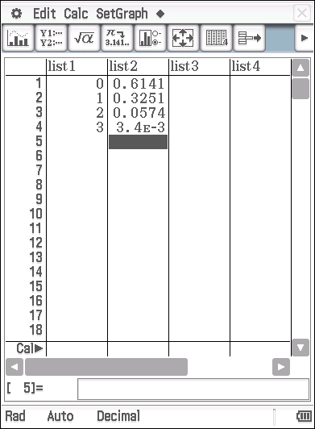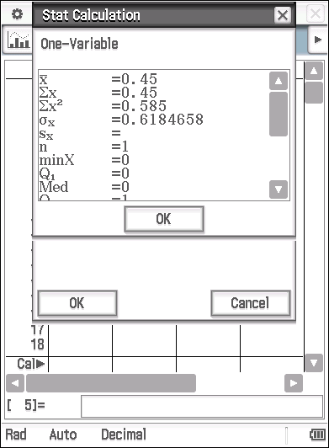
Marking key/mathematical behaviours | Marks
- States the correct mean  - States the correct standard deviation | 1  1

Question 14(a)(i)
Solution
$\frac{dy}{dx} = e^{x}+xe^{x}- e^{x}$
$= xe^{x}$
Marking key/mathematical behaviours | Marks
- correctly differentiates using the product rule | 1

Question 14(a)(ii)
Solution
$$\int_{0}^{1}{\left(xe^{x}+ x^{3}\right) dx} = \left.xe^{x}- e^{x}+ \frac{x^{4}}{4} \right]{1 \atop 0}$$

= $e-e+ \frac{1}{4} - (0-1+0)$

= $\frac{5}{4}$
Marking key/mathematical behaviours | Marks
- correctly integrates using the substitution from (i)  - evaluates correctly | 1  1

Question 14(b)
Solution
$$\int_{1}^{4}{\left(2f\left(x\right)+3x\right) dx} = 2 \int_{1}^{4}{f\left(x\right)+x dx+ \int_{1}^{4}{x dx}}$$
= 2 x (2) + $\frac{x^{2}}{2}|{4 \atop 1}$
= 4 + 8 − $\frac{1}{2}$
= 11$\frac{1}{2}$
Marking key/mathematical behaviours | Marks
- expands the integral, clearly displaying integration rules  - integrates x correctly  - correctly evaluates | 1  1  1

Question 15(a)

Solution
$$\int_{0}^{9}{kx^{\frac{1}{2}} dx = 27}$$

$$\int_{0}^{9}{kx^{\frac{1}{2}} dx = \frac{2}{3}} k\left.\sqrt{x^{3}} \right]{9 \atop 0}$$
= $18k$

$$18k=27$$
$k = \frac{3}{2}$
Marking key/mathematical behaviours | Marks
- correctly integrates  - correctly substitutes limits  - correctly solves | 1  1  1

Question 15(b)

Solution
(i) a = –2.658, b = 0, c = 0.978

(ii)

(iii) Area = 2.244 square units

Marking key/mathematical behaviours | Marks
- states correct values of a, b and c for part (i)  - states correct integral for part (ii)  - correctly solves for the area in part (iii) | 3  2  1

Question 16(a)
Solution
Probability that a computer is defective is 0.05
Probability that two are defective (out of 15)
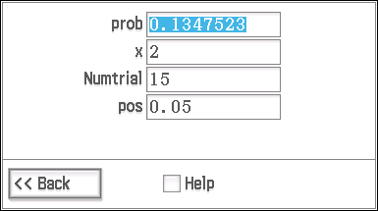
Marking key/mathematical behaviours | Marks
- Recognises the Binomial distribution  - Uses the appropriate binomial parameters  - States the correct value for the required probability | 1  1  1

Question 16(b)
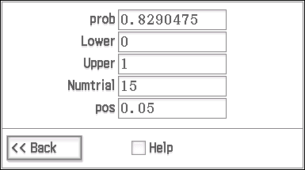
Solution
Probability that less than two computers are defective
means that one is defective or none are defective

Marking key/mathematical behaviours | Marks
- Recognises equivalence to one or none, defective  - Determines the correct probability | 1  2

Question 16(c)
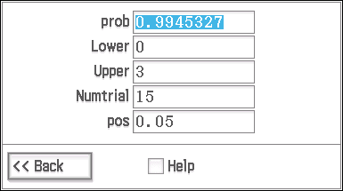
Solution
Probability that four or more are defective

Marking key/mathematical behaviours | Marks
- Recognises equivalent to less than 4 defective (3 or less are defective)  - States the correct result | 1  1

Question 16(d)
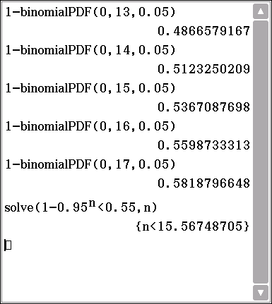
Solution
Using P(at least 1)=1 – P(0) and testing
n = 13, 14, 15,16,17 etc.
Largest sample is 15.

OR using solve

Marking key/mathematical behaviours | Marks
- correctly uses complementary event and tests suitable numbers for n  - determines correct sample size | 1+1  1

Question 17(a)
Solution
Alternatively,
Marking key/mathematical behaviours | Marks
- States the number of ways of selecting two red  - States number of selection in sample space | 1  1

Question 17(b)
Solution
Alternatively, on a CAS
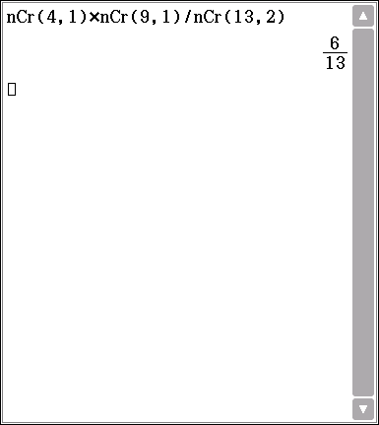

Marking key/mathematical behaviours | Marks
- States the correct method of selecting a red and a black marble  - States the correct result | 1  1

Question 17(c)
Solution
y | 0 | 1 | 2 | 3

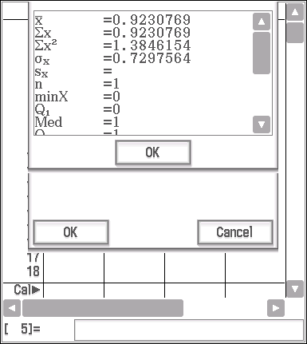
Using the statistics App on the calculator, mean = 0.9230769 and
standard deviation = 0.7297564
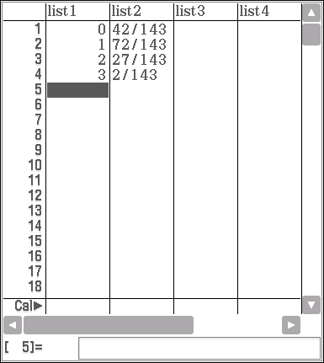
Marking key/mathematical behaviours | Marks
- Identifies the correct number of values for y  - Correctly calculates the probability for one of the y values  - Correctly states all four values  - States the mean of $y$  - States the standard deviation of $y$ | 1  1  1  1  1

Question 17(d)
Solution
- Without replacement, the distribution of is Binomial with
Hence the mean = , and the standard deviation is
Alternatively, may determine the probability density function for either as per the table below or using Statistics App of a CAS calculator
z | 0 | 1 | 2 | 3

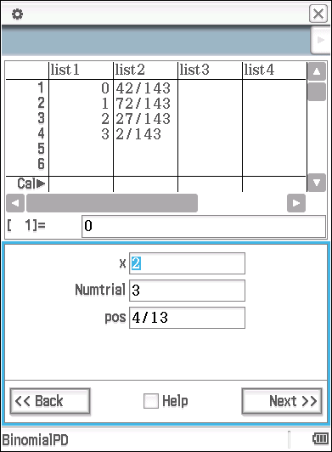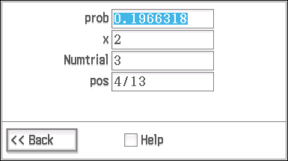
The mean and the standard deviation may then be easily determined on a CAS calculator as shown below
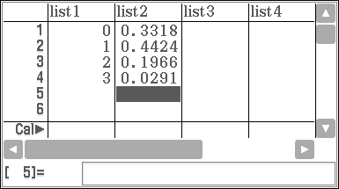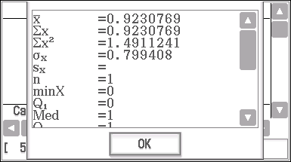

- Now, comparing with the mean and standard deviation without replacement as given it may be concluded that the means with and without replacement are the same but the standard deviation without replacement < standard deviations with replacement.
Marking key/mathematical behaviours | Marks
- Recognises the situation with replacement as producing a Binomial distribution  - Determines the mean and SD of z  - Compares the means and draw the appropriate conclusion  - Compares the SD and draws the appropriate conclusion | 1  1+1  1  1

Question 18(a)

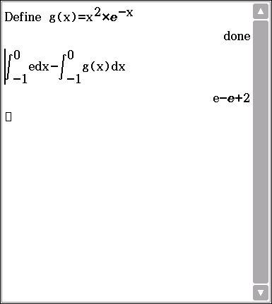
Solution
Determines the point of intersection of the curve and the line as
A = $\int_{-1}^{0}{e dx - \int_{-1}^{0}{g\left(x\right) dx}}$
= 2 sq units
Marking key/mathematical behaviours | Marks
- determines both parts of the integral statement  - evaluates the area correctly | 2  1

Question 18(b)

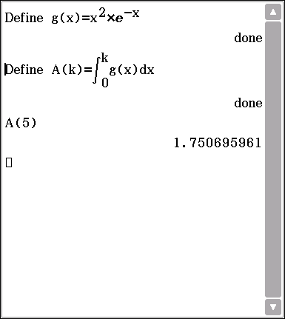
Solution
A(5) = $\int_{0}^{5}{g\left(x\right)dx}$
= 1.7507 sq units
Marking key/mathematical behaviours | Marks
- determines the integral statement  - evaluates the area correctly | 1  1

Question 18(c)

Solution
$f^{'}\left(x\right)= e^{-x}\left(x^{2}+2x+2\right)+ \left(2x+2\right)\left(-e^{-x}\right)$

$= x^{2}e^{-x}+2xe^{-x}+2e^{-x}-2xe^{-x}-xe^{-x}$

$= x^{2}e^{-x}$
$= g(x)$
Marking key/mathematical behaviours | Marks
- uses the product rule and correctly differentiates  - simplifies and shows equality | 1+1  1

Question 18(d)

Solution
$$A\left(k\right)= \int_{0}^{k}{x^{2}e^{-x} dx}$$
$= \left.- e^{-x}(x^{2}+2x+2)\right]{k \atop 0}$
$= -e^{-k}(k^{2}+2k+2)$
Marking key/mathematical behaviours | Marks
- correctly integrates and substitutes limits  - finds A(k) | 1  1

